

**AGM – Monday 8Th July 2024**

**What is a PTFA?**

A PTFA is a Parent, Teacher, and Friends’ Association, a charity run by members of the community connected with the school in question. With a common goal to build community, host fun events for the children, and raise funds to benefit the school and the children, our PTFA was created near the beginning of 2022. It began when a group of parents from the school’s first-year group came together to help the school in any way needed. We became an official PTFA in July 2022 when we held our first Annual General Meeting (AGM). Since then, our committee has expanded and currently has members representing all the current year groups, and we hope to continue to do so in the future.

We have a variety of different positions in our committee, and each member has their own role to play in helping our charity run smoothly. At each AGM, our members have to be voted in by our school community, even if they have held positions in previous years. This gives other members of the community the chance to take over roles that are currently occupied. We’ve had a great team of dedicated parents this year, who have worked hard to create memorable events for your Highwoodian and sometimes even for the grownups!

So, I’d like to finish this introduction by saying a massive well done and thank you to the team. Your effort is appreciated, your achievements are already paying off, and you’ve all made an amazing and positive impact on our children’s school. You all should be so proud.

Nicole, Chair of PTFA

**What has the PTFA spent the money on?**

Since we set up in 2022, we have had three main goals for how we would spend the money raised. These were decided upon as a committee of parents and teachers at our first AGM.

1. To create a library at Highwood Copse
2. To create a fund for small play equipment that can be topped up on a yearly basis
3. To raise funds and get installed a large piece of play equipment

Alongside this we also have the aims to build a strong community and support the children's learning in any way we can.

We are really excited to share with you how we are doing with these goals.

**The Library**

We have purchased and installed shelving to create a corridor library for the children at Highwood Copse school.

Our first Sponsored read held last year raised a significant amount of money that the lovely people at Usborne books matched, meaning we now have a brilliant selection of Usborne books of all shapes and sizes that have started to fill our shelves.

Our second Sponsored read, held this year, raised a whopping £715 which has been handed directly to the school for them to make the next bulk purchase of books for the library.



We are hoping to purchase some soft furnishings for next year so the children have somewhere cosy to sit and read.

The library is currently a resource for children and teachers to use within the school, however we do not have a check out system for them to take them home. This may be something we have the capacity to do in the future. If you have any expertise in this area or a particular interest then do contact us with any ideas.

***How will this be maintained?***

We will hold a sponsored read each year around world book day and use the funds raised to maintain and stock the library.

We will aim to find a volunteer who would be happy to pop into the school on a weekly basis to sort the books and do a check of the books stocked - If you would be interested in this role please get in touch



**Small Play equipment**

We have purchased outdoor storage boxes that the children’s small outdoor play equipment can be kept in. As well as a range of outdoor toys such as skipping ropes, bats and balls, stilts, hoops, a water tray, a large connect 4 set amongst other things.

***How will this be maintained?***

Each year we will ask the teaching staff for a wish list for things for indoor and outdoor play equipment, and spend the funds we have allocated on these items, as well as any top up that is needed of the toys they already have.

**Other….**

Each year we have bought the children a gift from Santa at Christmas time that was either distributed at the Christmas fete in 2022 or in 2023 by Santa visiting each class room.

We have purchased a notice board for the outside of the school so that it is easier for everyone to know what is going on and to make it easier for us to keep in touch with you.

Last year we put together welcome packs from the PTFA to all the incoming parents of Sept 2023 and we will do the same this year and the years to follow. We have had some really lovely feedback regarding this and feel it goes a long way to our goal of building a strong sense of a welcoming community at our school.

**We also maintain**

* A lottery licence - for our raffles
* Our membership with parent kind - which provides us with support advice and our constitution as a charitable organisation and policies.

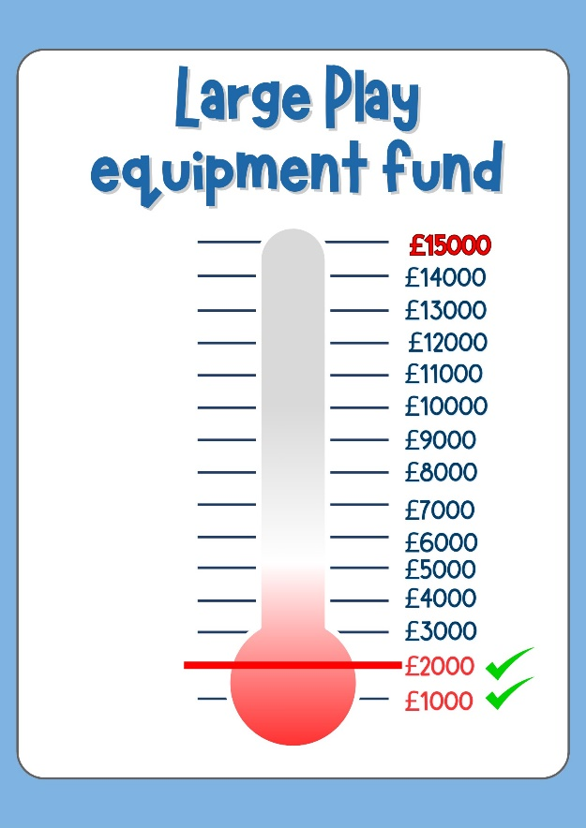Next Year……

Large Play Equipment

As the first two goals have started to get off the ground we have turned our focus to our biggest fundraising task. We would like to see and the children have expressed that they would like some climbing equipment, slides, and or obstacles trails for the older children's playground.

All the funds raised at this year's summer fete will kick off our fundraising for this, and we are off to a brilliant start with the fete bringing in over £1000.

We have made a thermometer which will live on the notice board so everyone can see the target and how close we are to it.

We are currently looking into grants with Greenham trust as well as possibilities with local construction companies through some of our parents with connections in the industry.

So, we are off to a good start, but as always if there is anything you think you can offer in terms of help, or connections to useful people then do let us know.

Other….

As well as our main projects we currently have a parent making welly racks to help with the welly storage situation, and the materials will be paid for from the PTFA funds which we hope to be completed by next year.

We also hope to buy a few things that might make the sports day experience a little better for all, such as a megaphone, a gazebo for the kids that need a breakout space, and, maybe even a finishing tape!

None of this could have happened without the amazing support and participation we get form you the parents, the children and the teachers at Highwood Copse, it's a huge team effort so a big big thanks and well done for everyone's contributions!

How can you get involved?

New parents automatically become members of the PTFA when their child starts at the school. This inclusion opens up numerous opportunities to contribute and make a difference in the school community. The more people become involved, the more we can achieve and the easier it will be. Your involvement, no matter how small, can significantly impact our efforts.

Even if you have younger children at home or can only spare a small amount of time, there are many ways you can participate. Could you come to a meeting, help set up an event, serve food, or design a poster? Perhaps you have a professional skill you could help us out with? You don't have to come into the school; many of our volunteering tasks can be done from home. Whether it's graphic design, writing, accounting, or any other skill, your expertise can be incredibly valuable to our team.

We are looking to expand our volunteer base and are always seeking people to take on events or responsibilities throughout the year. For example, if you are good at written communication, we need someone to help us expand our match funding by crafting compelling blurbs and communications. This is just one of the many roles we're looking to fill at the moment. If you have a skill or passion that you think may benefit us, please let us know – we are sure we can find a role for you!

Not all of the jobs we need to be done during school hours or on the school premises. Most of the preparation work can be done at home with a cup of tea! Whether it's planning, coordinating, or creating materials, your contribution from home can still make a big difference. So, if you're interested in helping out, please reach out. Together, we can achieve great things for our school community.



How to contact us

**Email**

You can always get in touch by email at [highwoodcopseprimaryptfa@gmail.com](mailto:highwoodcopseprimaryptfa@gmail.com) and someone from the committee will respond to you.



**WhatsApp**

There is a committee member in each of the WhatsApp groups so this can sometimes be a good way to communicate with us if it's a quick question.



**In person**

If you're lucky enough to spot one of us in the playground do feel free to grab us if again you have a quick question or would like to express an interest in attending a meeting for example.



**Who are we?**

Currently the committee is made up of 8 members. 7 are parents with children in reception, year one and year two, and one teacher member. Here we are below with a few relevant facts about each of us.

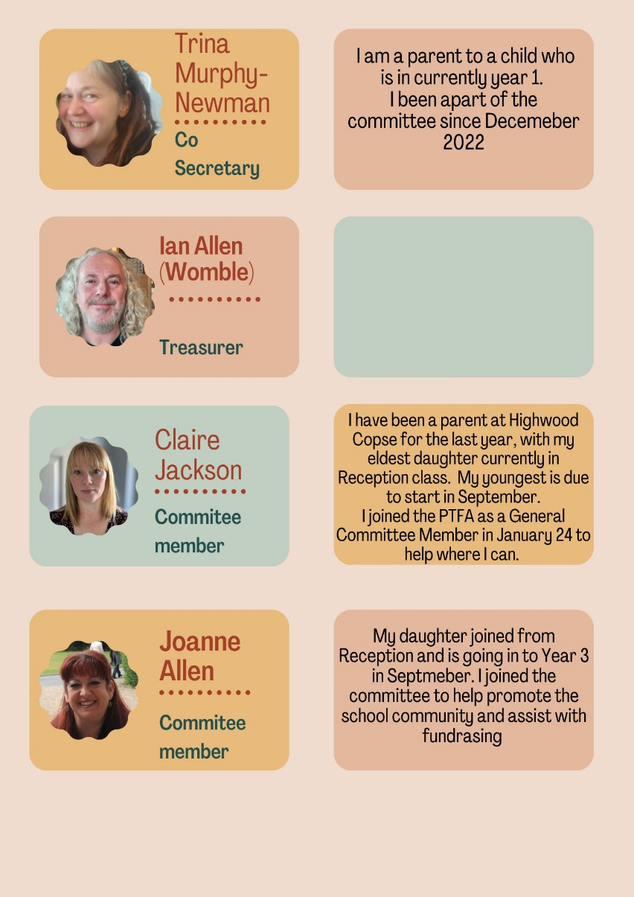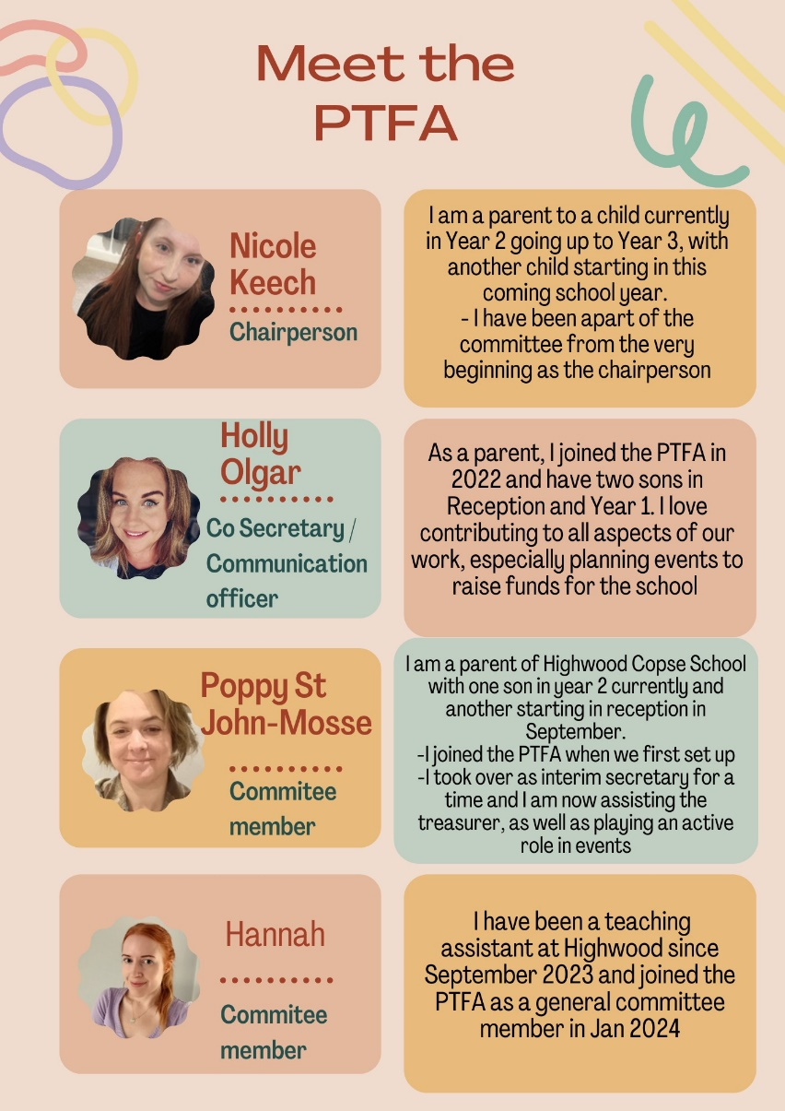



We’d love your input and feedback

If you’ve attended an event or taken part in something the PTFA has put on and feel like you have an idea that could be useful for next time, found something that could be improved upon, or have ideas for future events, we are always happy to hear from you.

We would ask that this type of feedback is given more formally via email or you can attend a committee meeting which takes place once a month and is normally held on the second Monday of the month. This means one, that we have a record of it, and two, that the PTFA members can respond as a committee.

It can be hard to respond to this type of feedback at school as we are often in parent mode/on the way to work or at the end of a long shift, when dropping off or picking up, rather than committee member mode. As I'm sure you can empathize with.

But thoughtful feedback is always welcome and can really enhance our events which the summer fete this year was a testament to!

To conclude our second year as a PTFA

I just wanted to say a special thanks to everyone who has supported us. We’ve had some wonderful external vendors from our local community who came out and showcased their goods, with some becoming regulars, which is amazing! Emma with Usborne Books also gave us an amazing deal, providing an additional £600 worth of books for FREE from our Read-a-thon earnings near the beginning of the year. This has been an incredible boost to making our library a magical place for the Highwoodian!

We’ve had some delicious sweet treats at our Summer Fayre from Rossi’s Ice Cream Van and Bakes by Jodi, both of whom gave us wonderful donations towards our charity and raffle and are keen to join us again in the future. We’ve had many generous external companies offer us wonderful prizes and vouchers for our raffles, which have been a great success! Beautiful craft stalls and jewellery stalls have been hosted by PTFA members, adults, teachers, and family members of our Highwoodian. A massive thank you to all of you; you’ve made our events magical and helped us reach our goals!

Another big thank you to all our regular volunteers. It is so important that we have regular volunteers to help us make our events as smooth and safe as possible, and we are grateful for all the support we’ve received in this area! It’s great to see we have many Years 1 and 2 helpers as well; you’re all super! Thank you to the teachers and TAs who have stayed later to help support our events and to Miss Robinson, who has continuously supported our events, valued our input, and trusted our ideas. We could not have had another amazing year without everyone playing their part and all the wonderful adults who have attended our events, donated prizes, donated money, and provided us with contacts. So once again, thank you for being an amazing and supportive community!

We look forward to hosting the last event of the year next week, the End of Year Disco.

**The Highwood Copse PTFA team.**

